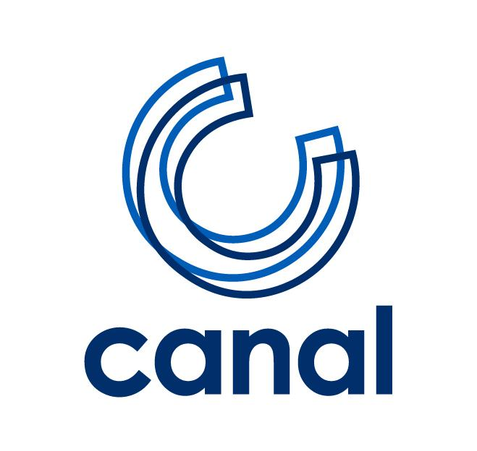

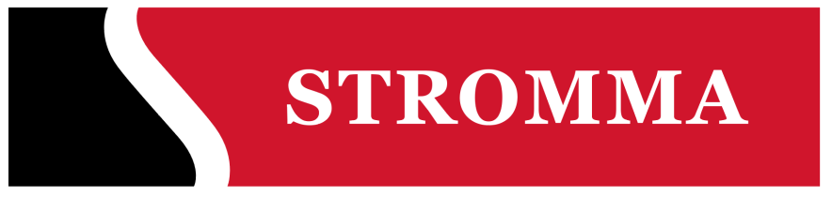

PRESS RELEASE

NEW BRAND STRATEGY FOR CANAL COMPANY

Amsterdam, 18 January 2017 – Canal Company, a familiar face on the Amsterdam canals, is part of Stromma Group since June 2016. At the start of the new tourist season (23 March 2017) Stromma will also be visible as a brand. The shipping company will change its name to Stromma Netherlands and introduces a new identity with the brands Stromma.com, Canal Tours Amsterdam and Hop On Hop Off. The collaboration with Gray Line will remain unchanged. As part of the international Stromma Group, the company will reinforce its position in the areas of sustainability, digitalisation and marketing in the coming period.

New year, new brand
Stromma Netherlands will kick-off the new season with the new brand positioning. Before the start of the new season, the shops and moorings will be branded in the Stromma.com look and feel, as well as the Canal Tours Amsterdam and Hop On Hop Off product brands. The ships and pedal boats will be rebranded step-by-step throughout the season. The company strives to have a sustainable design and colours that are appropriate to the environment and local guidelines. A strong online brand and presence is increasingly important for the visitors’ selection process. The new website stromma.nl will be launched before the start of the new season. This site is more modern and mobile-friendly for making reservations, online booking and e-ticketing. The new site stromma.com will be launched in February as the international brand for all destinations of Stromma Group.

Love for Amsterdam
Peter Duwel, CEO of Stromma Netherlands: “We are changing our name and brand, but we continue to be an Amsterdam company. The tourist sector in Amsterdam is changing and the number of tourists is still growing. We want to contribute to new solutions that will spread the visitors to areas outside of the city centre. Our Amsterdam Harbour Cruise and the partnership with A’DAM LOOKOUT are examples of this new approach. This shows that we are constantly renewing ourselves. But our main objective remains unchanged. We keep sharing our love for Amsterdam with visitors and aim to create lifelong memories. As Stromma Netherlands we are the host of Amsterdam, today and in the future!”

About Stromma Netherlands
Stromma Netherlands is the new name of Canal Company. Since spring 2016, this familiar face of Amsterdam has been part of the Swedish Stromma Group (Strömma Turism & Sjöfart). As of the 2017 tourist season, this name will also be visible on the canals. With a long history that started with Rederij Bergmann in 1912 and Meijer’s Rondvaarten (in the ‘20’s), the company became Amsterdam’s oldest and biggest shipping company.

Stromma Netherlands aims to be Amsterdam’s most hospitable and inspiring tourist company with its brands ‘Stromma.com’, ‘Canal Tours Amsterdam’ and ‘Hop On Hop Off’. The company hosts 1.5 million guests annually for the ultimate Amsterdam experience on 32 cruise ships, one passenger ship on the IJ, 14 open boats, 3 classic saloon steamers and 100 pedal boats. As part of the Stromma Group, there will be increased cooperation in the areas of sustainability, digitalisation and marketing.

Stromma has been active in shipping and tourism in Sweden, Norway, Finland and Denmark for two centuries. The name comes from strömma, the Swedish word for ‘flow’ or ‘current’. The company considers sustainability as a high priority that fits in well with Canal Company that has a Golden Green Key certificate. Environmental pressure is minimised as much as possible by the increased use of electricity instead of natural gas and hybrid diesel-electric engines.
New solutions such as the Amsterdam Harbour Cruise and the A’DAM LOOKOUT help spread visitors to areas outside of the city centre. For further information, visit stromma.nl and stromma.com (from mid-February 2017).

Editorial note, not for publication
For further information, questions and/or high resolution images, please contact:

Fair Focus Communicatie
Contact Annelies Putman Cramer
Telephone + 31 6 53215475
Email Annelies@fairfocuscommunicatie.nl

